Administrative and Academic Staff Guide:
Contents:
• Completing the mobility contract
• Flight tickets
• Contacts/official photos/gifts
• Contact information

Completing the mobility contract:
Filling out the application starts with the mobility agreement. Academic and administrative staff mobility agreements can be downloaded from here.
Teaching - for academic staff, Training - for administrative staff.
Completing the administrative/academic staff mobility agreement:

First of all, filling in the information begins with indicating the mobility period - "Planned Period of the activity: eg: 27.06.2023 - 03.07.2023, the candidate must also indicate the duration of the mobility (short-term mobilities are mostly one week, the number of days is indicated excluding the days of departure) - i.e. 5 day.
The name and surname of the participant, the name of the university (Georgian American University) should be indicated in the upper right corner.
მობილობის ხელშეკრულება ივსება ინგლისურ ენაზე.
"The Staff Member" - in this section general information of the administrative/academic staff is filled, Last Name, First Name, Seniority: (if less than 10 years have passed since the candidate has been working in the mentioned field, then Junior should be indicated, if from 10 up to 20 years - then Intermediate, if more than 20 years - then Senior) (the mentioned information can be verified in the appendix of the same document), Nationality (citizenship, not ethnicity), Sex/Gender, Academic Year - if the departure takes place in the autumn semester of 2023, then the specified 2023-24 year should be taken, Email - GAU email of the candidate.
The sending Institution: In this section, the information of the Georgian American University should be filled. Erasmus Code - this graph is not filled, in the Country/country code it is written - GE, in Faculty/Department - which faculty, department does the mentioned person represent, for example: Department of International Relations, Department of Humanities...etc.. Contact person name and position – Tamara Mechurchlishvili, Head of International Relations Department; Contact person e-mail: t.mechurchlishvili@gau.edu.ge.

The Receiving Institution/ Enterprise: This column contains the information of the receiving university (information can be found using "Google"). Type of Enterprise - University, Size of enterprise - the number of people employed by the mentioned university should be indicated here.

“Section to be completed before the mobility”:
English should be specified in Language of training.
The rest of the questions in this section should be answered based on the goals of participating in the mobility. Overall Objectives of the mobility - this part should indicate the general objectives of the candidate's mobility, Added value of the mobility - why the said mobility is important for the candidate, Activities to be carried out - what activities will the candidates carry out during the mobility period (lectures, visits to departments, etc.) ), expected outcomes and impact - expected results of mobility.

The name and surname of the candidate (who fills out the application) must be indicated in the staff member, the signature and date must be indicated on the bottom line. The receiving institution - this part is signed by the receiving university. The applicant should send the mentioned document to the receiving university for signature after the selection of his candidacy and the signature by the International Department of the Georgian American University.

Flight tickets:
It is best to purchase the flight tickets soon after the selection of candidacy. Staff buy tickets at their own expense, the said amount will be reimbursed (by the host university) during the visit or a few days after the end of the visit. There are several options for receiving money: cash payment, credit card. A certain amount of money is allocated for flight tickets, depending on the distance.
The candidate can calculate the cost of the trip using a special calculator: http://ec.europa.eu/dgs/education_culture/tools/distance_en.htm
And then be guided by the mentioned: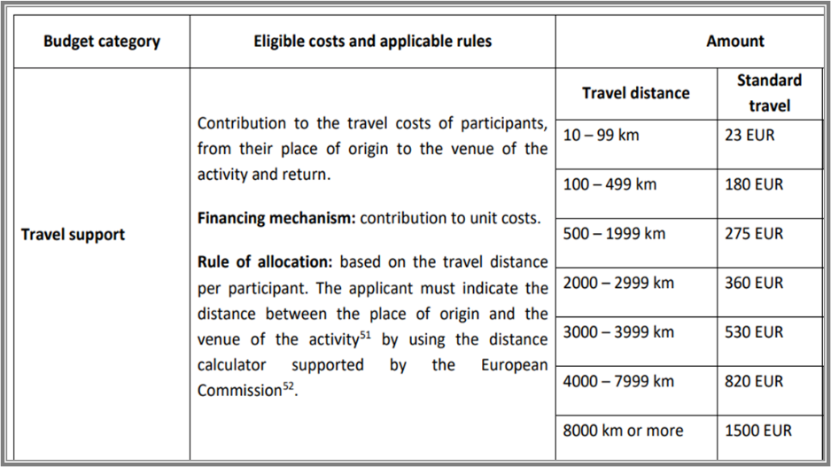
Amount issued per day by country:

Contacts/Official Photos/Gifts:
It is necessary to take official photos during the visit to the host university (together with the representatives of the host university). These photos will be published on GAU's website.
Also, the selected candidate should forward the contact information/business cards obtained after the visit to the receiving university to the International Relations Department of GAU.
It is necessary for the candidates to take GAU branded gifts with them when leaving - they should contact the International Relations Department of GAU for this information.

contact information:
In case of additional questions - contact information: t.mechurchlishvili@gau.edu.ge

